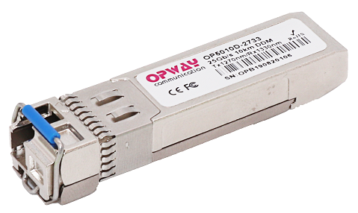

Features:
- UP to 25.78Gb/s bi-directional data links
- Hot-Pluggable SFP28 footprint
- Single LC for Bi-directional Transmission
- 1271nm DFB laser transmitter for OP5030D-2733, OP5030DI-2733
- 1331nm DFB laser transmitter for OP5030D-3327, OP5030DI-3327
- Up to 30km on 9/125um SMF
- 2-wire interface for management specifications compliant with SFF 8472 digital diagnostic monitoring interface for optical transceivers
- Power Supply :+3.3V
- Operating case temperature Range:
Commercial: 0~ 70°C
Industrial:-40~ 85°C
- RoHS compliant

Applications:
- 25GE ER Lite
- eCPRI&CPRI

Part Number Ordering Information
OP5030D-2733 | SFP28 30km BIDI optical transceiver with full real-time digital diagnostic monitoring ,1271nm Transmitter&1331nm Receiver,0~70℃, 25GE
OP5030D-3327 | SFP28 30km BIDI optical transceiver with full real-time digital diagnostic monitoring , 1331nm Transmitter&1271nm Receiver, 0~70℃, 25GE
OP5030DI-2733 | SFP28 30km BIDI optical transceiver with full real-time digital diagnostic monitoring ,1271nm Transmitter&1331nm Receiver,-40~85℃, 25GE
OP5030DI-3327 | SFP28 30km BIDI optical transceiver with full real-time digital diagnostic monitoring , 1331nm Transmitter&1271nm Receiver, -40~85℃, 25GE

Description:
OPWAY's OP5030D-XXXX/OP5030DI-XXXX SFP28 transceivers are designed for use in Ethernet links up to 25.78 Gb/s data rate and up to 30 km link length. They are compliant SFF-8472 , and compatible with SFF-8432 and applicable portions of SFF-8431. The product is RoHS compliant and lead-free per Directive 2011/96/EU.

  - Pin Function Definitions
PIN # | Name | Function | Notes
1 | VeeT | Module transmitter ground | 1
2 | Fault | Module transmitter Fault | 2
3 | Disable | Transmitter Disable; Turns off transmitter laser output | 3
4 | SDL | 2 wire serial interface data input/output (SDA) | 4
5 | SCL | 2 wire serial interface clock input (SCL) | 4
6 | MOD-ABS | Module Absent, connect to VeeR or VeeT in the module | 2
7 | RS0 | Rate select0: module inputs and are pulled low to VeeT with > 30 kΩ resistorsin the module.
8 | LOS | Receiver Loss of Signal Indication
9 | RS1 | Rate select1: module inputs and are pulled low to VeeT with > 30 kΩ resistorsin the module.
10 | VeeR | Module receiver ground | 1
11 | VeeR | Module receiver ground | 1
12 | RD- | Receiver inverted data out put
13 | RD+ | Receiver non-inverted data out put
14 | VeeR | Module receiver ground | 1
15 | VccR | Module receiver 3.3V supply
16 | VccT | Module transmitter 3.3V supply
17 | VeeT | Module transmitter ground | 1
18 | TD+ | Transmitter non-inverted data out put
19 | TD- | Transmitter inverted data out put
20 | VeeT | Module transmitter ground | 1
Note:
- The module ground pins shall be isolated from the module case.
- This pin is an open collector/drain output pin and shall be pulled up with 4.7K-10Kohms to Host_Vcc on the host board.
- This pin shall be pulled up with 4.7K-10Kohms to VccT in the module.
- This pin is an open collector/drain output pin and shall be pulled up with 4.7K-10Kohms to Host_Vcc on the host board.
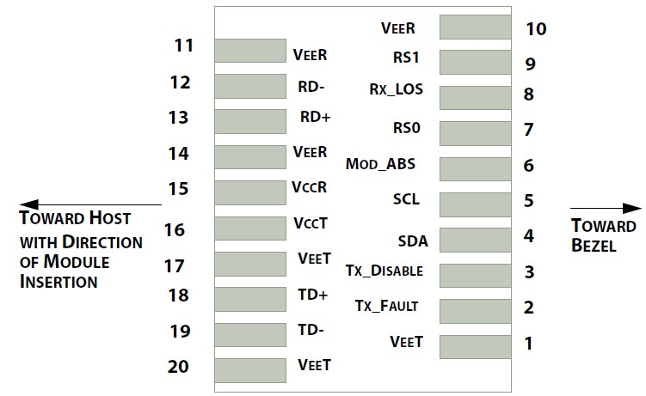

Diagram of Host Board Connector Block Pin Numbers and Names
- Absolute Maximum Ratings
Parameter | Symbol | Min. | Typical | Max. | Unit | Note
Storage Temperature | T_{S} | -40 |  | +85 | °C
Case Operating Temperature | T_{c} | 0 |  | +70 | °C | Commercial
Case Operating Temperature | T_{c} | -40 |  | +85 | °C | Industrial
Maximum Supply Voltage | Vcc | 0 |  | 3.6 | V
Relative Humidity(Non-condensing) | RH | 0 |  | 85 | %

- Electrical Characteristics
Parameter | Symbol | Min. | Typical | Max. | Unit | Note
Supply Voltage | Vcc | 3.14 |  | 3.46 | V
Supply Current | Icc |  |  | 450 | mA | Industrial
Power Consumption | P |  |  | 1.5 | W | Industrial
Data Rate | R |  | 25.78 |  | Gb/s
Fiber Length | L |  |  | 30 | KM
Transmitter Section:
Input differential impedance | R_{in} |  | 100 |  | Ω | 1
Differential input voltage swing | Vin,pp | 180 |  | 450 | mV | 2
Transmit Disable Voltage | V_{D} | 2 |  | Vcc | V | 3
Transmit Enable Voltage | V_{EN} | Vee |  | Vee+0.8 | V
Receiver Section:
Single Ended Output Voltage Tolerance | V | -0.3 |  | 4 | V
Rx Output Diff Voltage | Vo | 180 |  | 450 | mV
LOS Fault | V_{LOS fault} | 2 |  | Vcc_{HOST} | V | 4
LOS Normal | V_{LOS norm} | Vee |  | Vee+0.8 | V | 4

Note:
- Connected directly to TX data input pins. AC coupling from pins into laser driver IC.
- Per SFF-8431 Rev 3.0
- Into 100 ohms differential termination.
- LOS is an open collector output. Should be pulled up with 4.7k – 10kΩ on the host board. Normal operation is logic 0; loss of signal is logic 1. Maximum pull-up voltage is 5.5V.
- Optical Characteristics
Parameter | Symbol | Min. | Typical | Max. | Unit | Note
Transmitter Section:
Center Wavelength | λt | 1260 | 1271 | 1280 | nm | 1271 Tx
 |  | 1320 | 1331 | 1340 | nm | 1331 Tx
spectral width (-20dB) | △λ |  |  | 1 | nm
Average Optical Power | Pavg | 0 |  | +6.0 | dBm
Laser Off Power | Poff |  |  | -30 | dBm
Side Mode Suppression Ratio |  | 30
Extinction Ratio | ER | 3.5 |  |  | dB
Optical Return Loss Tolerance |  |  |  | -20 | dB
Receiver Section:
Center Wavelength | λr | 1260 |  | 1370 | nm
Average Receiver Power | Sen | -19 |  | -7 | dBm
OMA Receiver Sensitivity | OMA |  |  | -19 |  | 1
Los Assert | LOS_{A} | -30 |  | - | dBm
Los Dessert | LOS_{D} |  |  | -20 | dBm
Los Hysteresis | LOS_{H} | 0.5 |  |  | dB
Overload |  | 2 |  |  | dBm

Note:
- Measured with a PRBS 2^31-1 test pattern, @25.78Gb/s, BER<5E-5.

  - Timing Characteristics
Parameter | Symbol | Min. | Typical | Max. | Unit
TX_Disable Assert Time | t_off |  |  | 100 | us
TX_Disable Negate Time | t_on |  |  | 2 | ms
Time to Initialize 2-wire interface | t_2w_start_up |  |  | 300 | ms
Time to Initialize | t_start_up |  |  | 300 | ms
Time to Initialize cooled module and time to power up a cooled module to Power level II | t_start_up_cooled |  |  | 90 | s
Time to Power Up to Level II | t_power_level2 |  |  | 300 | ms
Time to Power Down from Level II | t_power_down |  |  | 300 | ms
Tx_Fault assert | Tx_Fault_on |  |  | 1 | ms
Tx_Fault assert for cooled module | Tx_Fault_on_cooled |  |  | 50 | ms
TX_FAULT Reset | t_reset | 10 |  |  | us
Rx_LOS assert delay | t_los_on |  |  | 100 | us
Rx_LOS negate delay | t_los_off |  |  | 100 | us

  - Digital Diagnostic Specifications
Parameter | Symbol | Units | Min | Max | Accuracy | Note
Transceiver Temperature | Temp | ºC | -40 | +85 | ±5ºC | Industrial
 |  |  | 0 | +70 | ±5 ºC | Commercial
Transceiver Supply Voltage | Voltage | V | 3.15 | 3.45 | ±3%
Transmitter Bias Current | Bias | mA | 0 | 35 | ±10%
Transmitter Output Power | Tx-Power | dBm | -5 | +2 | ±3dB
Receiver Average Optical Input Power | Rx-Power | dBm | -12 | -2 | ±3dB

  - Recommended Circuit:
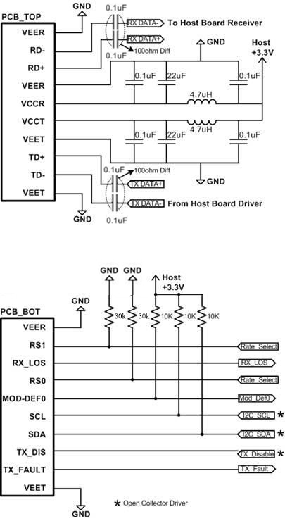
Recommended High-speed Interface Circuit

  - Mechanical Dimensions:

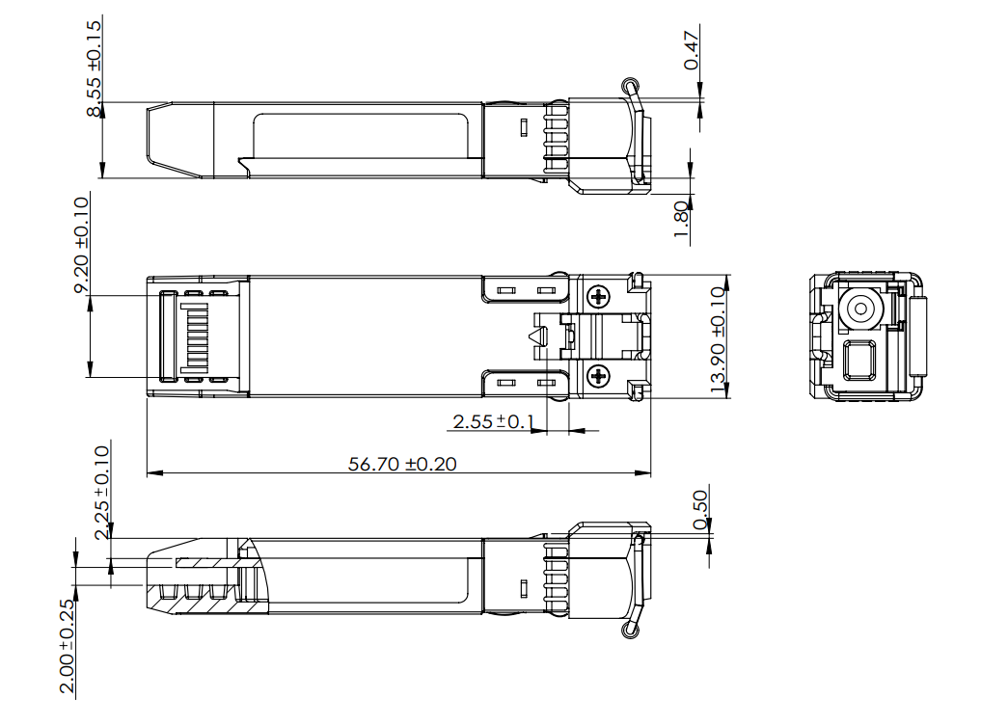

Published by Shenzhen OPWAY Communication Co., Ltd.
Copyright © OPWAY
All Rights Reserved

